Training Fiche

Title | Financial literacy
Keywords | Access to finance / Debt financing / Equity financing / Interest / Prices / Inflation
Provided by | IHF / LWL
Language | EN
Objectives | - Support women entrepreneurs in the comprehension of the main financial key aspects, through the acquisition of technical and practical knowledge and tools  - Provide the target group with some external financial opportunities and risks and related examples to take advantage of them
Learning outcomes | - Lay the first financial foundations for the creation of a new business or development of an existing one  - Be discretionary in the choice of financing tools, methods and timing  - Recognize external risk factors and have an example of how to deal with them  - learners can make a plan for the financial sustainability of a value creating activity - Advanced level of the EntreComp framework competence “Financial and economic literacy”
Training Area | Digital skills
 | Pricing and marketing
 | Access to finance from the female perspective
 | Leadership and Communication Skills
Content index | Module : Financial Literacy  Unit 1: Cost of financing and interest rates  Section 1: Financing cost  Section 2: Interest and interest rate  Section 3: Different types of rates  Unit 2: Debt vs Equity Finance  Section 1: Overview  Section 2: Debt financing: loans and borrowing  Section 3: Equity financing – best practice  Unit 3: Inflation  Section 1: Overview  Section 2: Inflation dashboard  Section 3: Why it matters  Section 4: How to manage it – best practice
Content development | Unit 1: Debt vs Equity Finance  Section 1: Financing cost  An enterprise funds its operations using two different sources:  - Equity financing  - Debt financing  Capital gains and dividends are required by equity investors, while debt providers seek interest payments.  Financing cost (FC), however, refers to the interest and other fees charged to debt financiers. Interest expense can be incurred on both short-term (less than a year) and long-term financing.  The cost, interest, and other charges associated with an enterprise’s money require to create, purchase assets, or carry out operations – setting up or developing a business – are referred to as financing cost.  Section 2: Interest and interest rate  The enterprises and the investors in general use the following formula to calculate financing cost:  (Total amount paid back – Total amount borrowed)  Interest cost =  Total amount borrowed  Simple interest  =  Principle amount  In order to better understand the concept of interest and thus financing cost, reference must be made to the interest rate by introducing the concept of time, i.e. the time required to repay the financing.  Interest cost 🡪 annualised and compounded 🡪 Interest Rate  P = Principle amount = Total amount borrowed  SI = Simple Interest = Total amount paid back – P  t = number periods for a year  r = interest rate  (SI x 100)  r =  (P x t)  Example 1:  €100 r = ? €1400  t₀ t₁ = 24 months  P = 1000  Total amount paid back = 1400  SI = 1400 – 1000 = 400  t = t₀ – t₁ = 24/12 = 2  r = (400 x 100) / (1000 x 2) = 20%  20% is the interest rate – i.e. the portion of the financing that is charged as interest to an enterprise, expressed as an annual percentage of the outstanding financing.  Compound Interest (CI), also called interest on interest, is another method to calculate financing cost. It is applied to both the capital – principle – and the accumulated interest earned in prior periods.  At the end of the first year the enterprise owes the principle amount's portion plus interest for that year. At the end of the second year, the enterprise owes the principal's portion plus the interest for that year plus the interest on interest for the previous year. And so on.  So, when compounding (🡪 CI > SI), the interest owed is greater than the interest owed when utilising the simple interest approach.  CI = P x (1 + r)^{t} – P  Example 1:  P = 1000  SI = 400  t = 2  r = 20%  CI = 1000 x (1 + 0,20)² – 1000 = 440  440 > 400 🡪 CI > SI  For shorter time periods, the interest calculation will be similar for both methods – SI and CI. However, as the financing period lengthens, the discrepancy between the two forms of interest estimates rises, pending in favour of CI versus SI.  Section 3: Different types of rates  APR vs APY  Annual Percentage Rate (APR)  APR is the annual rate of interest without taking into account the compounding of interest within that year.  APR = Periodic Rate x Number of Periods in a Year  Annual Percentage Yield (APY)  APY does take into account the effects of intra-year compounding.  APY = (1 + Periodic Rate)^{Number of periods} – 1  Example 2:  A credit card company might charge 1,5% interest  APR = (1,5% x 12 months) = 18%  APY = (1 + 0,015)¹² – 1 = 19,56%  You will be charged the comparable yearly rate of 18% if you just hold a debt on your credit card for one month. However, if you hold that sum for the entire year, your effective interest rate rises to 19,56% due to monthly compounding.  Online APR APY calculator:  https://www.aprtoapy.com/  Unit 2: Debt vs Equity Finance  Section 1: Overview  The debt-to-equity ratio (D/E) indicates how much of an enterprise’s financing is provided by debt and equity in proportion.  Total Debts  D/E =  Total Shareholders’ Equity  Generally, 0,5 < D/E < 1,5 is considered good in terms of enterprise’s risk.  Examples of Debt Financing  - Borrowing of the money  - Additional financial load on the enterprise  - Obligation to pay the money obtained back with interest  - Easy forecast costs  - Repayment schedule  Examples of Equity Financing  - Sale of a portion of enterprise’s equity  - Management business sharing  - Profit-sharing  - Easier access to the nascent stage  Section 2: Debt financing: loans and borrowing  LENDER: A lender is an individual, a group, or a financial institution who loans money with the expectation of repayment, typically with interest.  BORROWER: A borrower is an individual or entity – enterprise – who obtains money on credit, i.e. with the intention of returning it, typically with interest.  Loans are generally given by banks or private lenders and they are regulated through a formal loan agreement.  Regardless of who makes the loan, the borrower is required to repay it, with interest and within a set time frame. If the borrower fails to repay, the lender may have the right to take the borrower’s asset if collateral is provided – something used as security, in case the loan is not repaid.  Soft Loan: It is given with next-to-no or no interest with extended grace periods, that is more lenient than standard loans.  Tip: Grants are, in essence, gifts. Non-repayable. Grants can be given to individuals, businesses, educational institutions, or no-profits by government departments, trusts, or corporations. There are several parameters to access them.    An enterprise must be incorporated before a loan can be applied for  Section 3: Equity financing – best practice  The scale and scope of equity financing include a wide range of activities, from raising a few hundred dollars from friends and family to raising billions of dollars from huge organisations and a large number of investors in Initial Public Offerings.  Among the most common and well-known kinds outside equity funding are:  - Angel Investors: They are someone or groups – generally friends, family or professional investors – who invest their own money in a business. They have no claim on the day-to-day business management.  - Venture Capitalists (VC): They are professional and skilled investors who provide capital to selected enterprises. They can invest other people’s money.  - Initial Public Offering (IPO): An enterprise can source funds by offering and selling the shares to the public in a new stock issuance. From private ownership to public ownership.  - Crowdfunding: The method of funding a project or enterprise by raising money from a large number of people/investors who provide for a small account – as small as €1000 for each investor. It typically starts with an online “campaign” via one of the crowdfunding sites.  Best practice: Women TechEU – Supporting deep-tech start-ups led by women  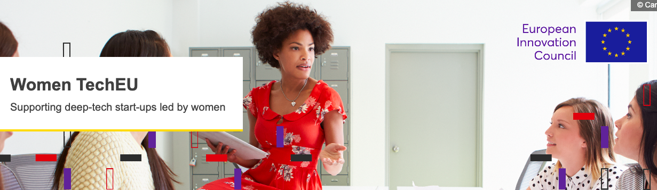  Funded under the programme Horizon Europe, Women TechEU is a new initiative of the European Union. The scheme offers first-class coaching and mentoring to female founders, as well as targeted funding to help take their business to the next level. This initiative offers among other things:  - Financial support to the company as an individual grant of EUR 75,000 to support the initial steps in the innovation process, and the growth of the company  - The possibility to participate in dedicated activities organised by InvestEU and Enterprise Europe Network  Unit 3: Inflation  Section 1: Overview  What is inflation? 🡪 Broad increase in prices  «In a market economy, prices for goods and services can always change. Some prices rise; some prices fall. Inflation occurs when there is a broad increase in the prices of goods and services, not just of individual items; it means, you can buy less for €1 today than you could yesterday. In other words, inflation reduces the value of the currency over time.  (…)  All the goods and services consumed by households during the year are represented by a “basket” of items. Every product in this basket has a price, which can change over time. The annual rate of inflation is the price of the total basket in a given month compared with its price in the same month one year previously».  Source: European Central Bank  Section 2: Inflation dashboard  Consumer price inflation in the Euro area is measured by the “Harmonised Index of Consumer Prices” (HICP).  Who calculates the HICP?  Eurostat, the Statistical Office of the European Communities  For latest HICP data and future update can be accessed via the link www.ecb.europa.eu/inflation/stats  Section 3: Why it matters  Inflation has a wide-ranging impact on the economy. It affects individual spending power, business investments, interest rates, tax policies, government programs, national debt, and also other aspects.  Why does increased inflation matter for a woman digital entrepreneur?  - Increased costs in general  - Decreased purchasing power  - Increased interest rates 🡪 greater financing difficulties  - Difficulties in pricing which result in increases – because the inflation is a price lever  - Overall macroeconomic uncertainty 🡪 reduction in economic activity 🡪 stunt economic growth  Section 4: How to manage it – best practice  The main players for addressing inflation are the central banks – the European Central Bank (ECB) in the European case – and central governments, through a number of monetary policy tools.  However, what can an entrepreneur do in her own small way to address inflation in the short term, to ensure business continuing growth and that rising costs do not weigh on prices – increasing them – and thus on the end consumer? So, what can she do to manage the inflation?  Best practice: SHRINKFLATION  Shrinkflation: same price, same packaging, but less product inside. It is a strategy chosen by some enterprises in order not to make consumers perceive the price increase due to inflation and to avoid a decrease in spending and consumption.  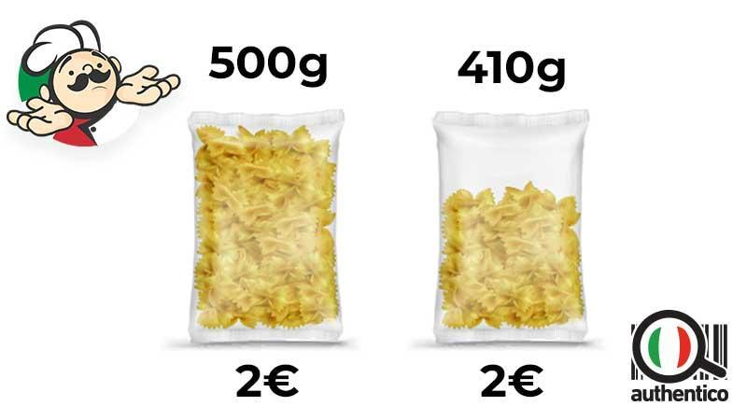  Before: 500g 🡪 €2  After: 440g 🡪 €2  Summing up  Financing 🡪 Access to Finance / Financing cost / Interest / Interest rate / Debt financing / Equity financing / Women TechEU  Inflation 🡪 Increase / Prices / Purchasing power / European Central Bank / Eurostat / HICP / Shrinkflation
Glossary | /
Self-evaluation (multiple choice queries and answers) | 1. For a lengthening financing period, what is the rapport between the two forms of interest?  a) CI = SI  b) CI < SI  c) CI > SI  2. Who is a borrower?  a) an individual, a group, or a financial institution who loans money with the expectation of repayment, typically without interest  b) an individual or entity – enterprise – who obtains money on credit, i.e. with the intention of returning it, typically with interest  c) an individual or entity – enterprise – who obtains money on credit, i.e. with the intention of returning it, typically without interest  3. How is it called the method of funding a project or enterprise by raising money from many people who provide for a small account, with an online “campaign”?  a) Crowdfunding  b) Initial Public Offering (IPO)  c) Angel Investors  4. What is caused by a broad increase in prices and reduces the value of the currency over time?  a) Stagflation  b) Deflation  c) Inflation  5. What does the shrinkflation technique involve?  a) same price, same quantity  b) less price, same quantity  c) same price, less quantity
Bibliography | https://www.investopedia.com/terms/c/costofcapital.asp  https://www.investopedia.com/ask/answers/042215/what-are-benefits-company-using-equity-financing-vs-debt-financing.asp  https://www.rocketlawyer.com/business-and-contracts/business-operations/corporate-finance/legal-guide/grants-vs-loans-whats-the-difference  https://www.wallstreetmojo.com/apr-vs-apy/  https://www.ecb.europa.eu/stats/macroeconomic_and_sectoral/hicp/html/index.en.html  https://www.pgpf.org/budget-basics/what-is-inflation-and-why-does-it-matter
Resources (videos, reference link) | /

