Training Fiche Template

Title | Change Management
Keywords | Change Management, Leadership
Provided by | IRL
Language | EN
Objectives | - Understand Effective Leadership is effective Change Management  - Recognize the need for, and entrepreneurial value of a structured approach to Change Management  - Learn how to implement a structured Change Management plan
Learning outcomes | - Recognize possible internal and external causes of change  - Know what changes are likely to happen in an organisation.  - Map the Cause-and-Effect relationship of change management.  - Recognize the Value and Potential role of Change Management in the context of their own business.  - Understand Kotter’s Change Management Model  - Apply the practise of Kotter’s Change Management to their own business practise or business plan development
Training Area | Digital skills
 | Pricing and marketing
 | Access to finance from the female perspective
 | Leadership and Communication Skills | outsomce
Content index | Module X: Leadership & Change Management  Unit 1: Understanding Change Management  Section 1: Change v Change Management  Section 2: The Nature of Change in Business  Section 3: Change Management is Nothing new  Section 4: The Complexity of Change Management  Unit 2: Why is Change Management Difficult?  Section 1: Why is Change Management Difficult?  Section 2: Management v Staff Conflict  Unit 3: How to Manage Change  Section 1: Getting Started! SMART Goal Setting  Section 2: Kotter’s Eight Stage Change Management Process  Section 3: ‘Mary’s Café’ A Digital Change Management  Case Study
Content development | Unit 1: Understanding Change Management  Section 1: Change v Change Management  “The snake which cannot cast it’s skin has to die. As well the minds which are prevented from changing their opinions; they cease to be mind.”  Friedrich Nietzche  Change in business as in life has always been the only Constant. The significant difference today in the third decade of the 21st Century is that the pace of business change is accelerating at a pace unprecedented in human history. Trends, innovations and business cultures that in the past took maybe decades to unfold now can come and go in a few years and in their wake leave many businesses failures, big and small. While the Information Technology revolution of the past thirty or so years is widely recognized as the catalyst for this change, the pandemic in many ways has transformed business and work practises. It’s reasonable to suggest that the pandemic in many ways has changed enterprise, work and consumer norms in ways unexpected till sometime in the 2030’s. The Working from home option, real expectation of online service and online business communications seemingly overnight have become the business norm on a European if not global scale. This is really the tip of the iceberg in terms of change to be managed by any enterprise, competition, business performance both good and bad and navigating crisis such as recession, inflation, energy, staffing, the list goes on and on.  While meeting the Change challenge can seem daunting for the entrepreneur and there are countless examples of businesses that have put their head in the sand and have paid a heavy price as a result, a different way to look at things is to understand that change creates hope and opportunity – entrepreneurial hope and opportunity. Gaps for businesses that fully embrace digital opportunity now exist. Consumers have embraced (or reluctantly accepted!) the idea of changing their habits more quickly. Businesses can now reach their potential customer more easily than ever before. The marketplace for many business product and services is no longer confined by geography and today has become European and even global for even the smallest of businesses.  Your Business cannot avoid change, but Change Management involves more than reacting to this reality. Change Management is a planned structured business tool to realise the potential of your business. Change Management is an entrepreneurial effort to meet entrepreneurial opportunity.  Managing Change is the fundamental purpose of Leadership.  Section 2: The Nature of Change in Business  - The only thing that does not change in business is the need for change.  - Businesses need to constantly look at new ways of doing things because if they do not, they become uncompetitive and die.  - Businesses need to adopt the philosophy of continuous improvement & be constantly looking for ways to improve their processes.  The Change Management Vision  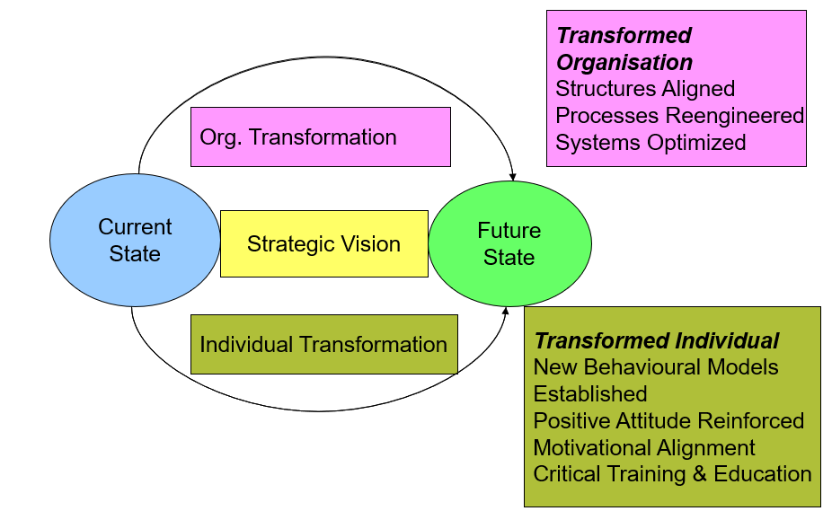  Section 3: Change Management is Nothing New  In common with all theories on Leadership, theories of Change Management have been heavily influenced from other trends in thinking and society. The disciplines of Engineering and Psychology particularly from the late 19th Century period of urbanisation and Industrialisation began to come together to help describe how change happens and how to manage change.  Scientific Management as developed by Frederick Taylor is a famous example of Change Management in Practise. Taylor suggested that production efficiency in a shop or factory could be greatly enhanced by close observation of the individual worker and elimination of waste time and motion in his Operation. Taylor’s ideas have strongly influenced Change Management thought and business model development for well over 100 years.  The Science of Psychology, the study of behaviour and mental processes is relatively new, emerging in the 19th Century and ever since then the importance of the discipline ensures that a people focused approach to Leadership and Change Management has had much influence. Understanding the significance of personnel change, job satisfaction, job security and insecurity, staff retention, morale, productivity and helping individual staff members understand what specific change might mean to them personally is all part of a psychology-oriented approach to Change Management. In modern, non-assembly line business, where staff are more involved that in older, more command-and-control environments, change management usually has to engage with staff to be effective.  Effective Change Management involves both the Mechanical (Technological) and human dimension. It’s always important to explore how both dimensions might interact in practise when planning new business change.  Section 4: The Complexity of Change Management  “Change Management is a structured approach to transitioning individuals; teams and organisations from a current state to a desired future state to fully implement a vision and strategy. Change Management is the formal process of organisational change. Change Management means defining and Adopting Corporate Strategies, structures, procedures and Technologies to deal with change stemming from Internal and External Conditions.” (Anon in Ryerston University 2011).  Structured Approach – Change Management is about structured planning, not hurried reaction.  People Transition – Change Management is a process of Transition of People from Practise A (Which is often well established, perhaps quite successful and comfortable to Practise B (Which involves ambition, risk and the unknown). It fundamentally is concerned with all the uncertainties of People Management.  Formal Process – Effective Change Management needs to be a formalised process, informal organic organisational change where change in an organisation just happens over time or as a natural reaction is not Change Management.  Definition and Adoption – A major key to successful Change Management is Communication. Clear definition and communication of the Challenge to be addressed and how, will go a long way towards addressing fears and getting the necessary level of buy-in and adoption necessary for success.  Section 5: Internal & External Causes of Change  Internal Causes of Change  The line between external and internal causes of change is often blurred. What can start as an External change driver often is the catalyst for internal change. Both sectors and individual organisations are subject to change. Many individual sectors in the economy have faced massive changes in recent years. Most dramatically major changes in Information and Communication Technology directly and indirectly affect almost all business models. Think about the Challenges of Air BnB for accommodation, JustEat for the Restaurant Trade, Amazon for book shops and Uber for transportation. Within sectors, individual organisations sometimes want to change some or all how they do things. Organisations may recognize obvious deficiencies in their processes or old-fashioned communication approaches for example. The need for change is often very obvious to the entrepreneur. The structured process of Change Management necessary to address those problems is less easy to navigate.  External Causes of Change  We know change has always been with us but a lot about our world has changed most significantly in recent times. Most of us didn’t fly or drive a car before 1950, didn’t own a tv before 1960, didn’t buy bottled water before 1980 and none of us surfed the web before 1990 or had a social media profile before 2005.  Europe in recent years has seen massive change with Migration, Economic Boom and Bust and Brexit all happening in a short time frame. Newly established gender norms, growth in secularisation and cultural and religious differences all contribute to economic upheaval. The pandemic overnight imposed unprecedented level of change obligation and there is hardly a European business that did not have employ major change, from making sales, deliveries and work practices, changes which in many cases are here to stay. Older certainties in business practise are no longer set in stone. Business Practise is in many ways more insecure than ever before with competition always intensifying. Engaging in Enterprise in such an uncertain environment might at first glance seem foolish, however it is most important to realize economic churn and transition brings clear opportunity for the bold and ambitious entrepreneur,.  There are numerous examples of how more successful businesses seek not just to react to external change drivers but to be ahead of the curve in their area or to move into areas they don’t currently operate in.  Unit 2: Why is Change Management Difficult?  Section 1: Why is Change Management Difficult?  Change management while the lifeblood of business survival, is very difficult. In 2000, a few short years prior to the financial crash Harvard Business Review found that 66% of change initiatives fail to achieve their desired business outcomes (Harvard Business Review, 2000).  The Day-to-Day stresses of business practise, orders to be filled, customers to be satisfied often times leaves little space for the perceived luxury of actually Managing Change as against scrambling to react to it. For any small business in particular, there’s usually a more immediate task to take priority. Managing Change requires honest, unemotional logic-based choices which for many leadership groups or individuals is not easy to reach.  Section 2: Management v Staff Conflict  Change Management may result in Management v Staff Conflict. A significant level of diplomacy and skills of negotiation of negation are required in leadership to bring staff successfully along the journey of change.  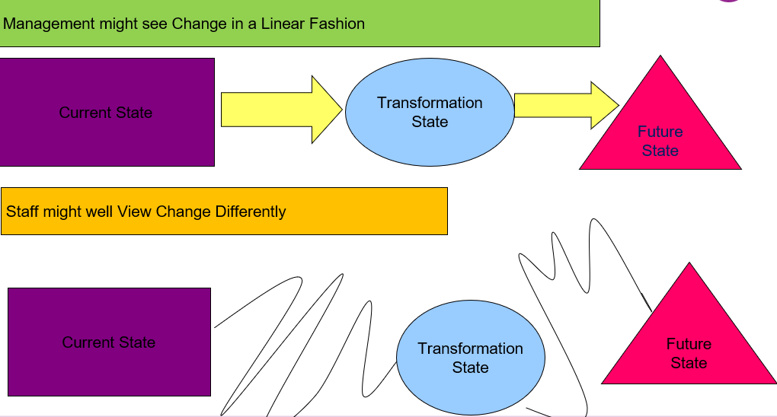  Unit 3: How to Manage Change  Section 1: Getting Started! SMART Goal Setting  - SMART Goals is a straightforward affordable, in both time and resources way to get any Change Management process started  - Very useful in framing and most importantly the communication of Definition & Adoption  - Makes it easier to help your organization prepare, conform, and accept the change in a streamlined way throughout the change process  - All about fast comprehension and acceptance  - Can be used as a Stand Alone change structure or be built on with a more complicated framework  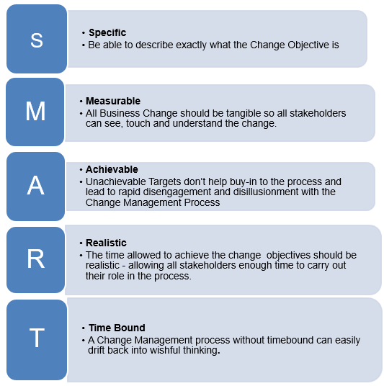  Section 2: Kotter’s Eight Stage Change Management Process  One meaningful and hugely popular theory which offers a framework wide and detailed enough to direct and manage the potential pitfalls of is Kotter’s Eight Stages of Change Management (Kotter, 1995, 1996,) Kotter Describes change as a process, not an event and provides something of a practical roadmap to follow. It is scalable, complimentary and if followed properly can bring structure to any Change Management project.  Kotter’s Eight Stages of Change Management  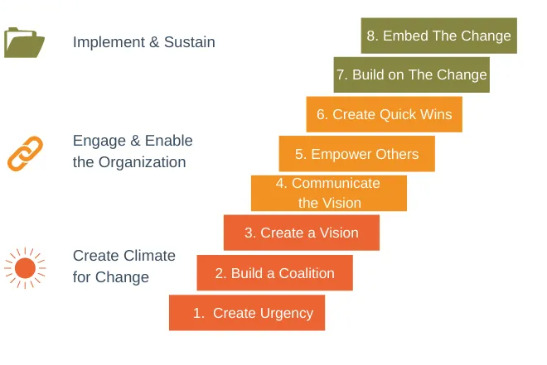  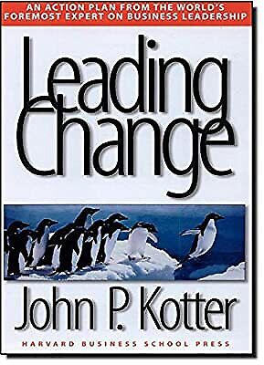  Section 3: ‘Mary’s Café’ A Digital Change Management Case Study  Mary opened her café in a small rural town in Spain in 2019. A large Information Technology multinational located 30 kilometres away is the major employer in the area. The business had to close on numerous occasions during the pandemic and as a result funds accumulated from a successful first year of trading have been severely depleted. Her business is very dependent on passing commuter trade as well as two local second level schools, both of which have now opened their own on campus subsidised cafetaria. Mary provides a limited external catering service on an ad-hoc basis. ‘Mary’s Café’ has a word of mouth reputation of having a friendly welcoming atmosphere, excellent food and a very experienced staff. Nevertheless, coming out of the pandemic and given soaring energy and input costs Mary is fearful that her café will not survive long into the future without some significant business practise change. Perhaps investment in Digitisation is the answer?  How might Kotter’s Eight Stages Of Change Management Help Mary?  Kotter’s Eight Stages of Change Management process can be applied to any business, small or large. Let’s examine how his approach might be applied to ‘Mary’s Café’.  Step One: Create Urgency  For Kotter only when 75% of a company’s management are convinced that business-as-usual is unacceptable is the required urgency present. From the outset, Kotter’s plan is based on subjectivity which is there to be shaped and directed. In the case of ‘Mary’s Café’, Urgency should be very obvious to staff and management.  The causes of the decline in trade are very clear to see and should be relatively easy for Mary to communicate in a non-confrontational way. While Mary sees Digital Technology as the key to future opportunity, negative urgency is easier to harness than the more elusive positive Missed Opportunities digital skills brings.  Step Two: Build a Coalition  Mary employs two supervisors with fifty years combined experience in the catering business. Neither really have bought in to the need for digital transformation, have limited confidence in their digital skills and as a result are fearful of and resistant to this change. Without buy-in of these supervisors to the digital transformation project, Mary faces an uphill battle.. One of the most effective ways to garner buy in to a process is demonstration. With fairly limited effort Mary can effectively demonstrate the success of an increased social media presence and with some limited training investment can empower her supervisors to drive this change based on small, incremental steps.  Step Three: Create a Vision  Underestimating the Power of Vision. Vision is crucial to Change. Change without destination makes no sense. The first task for Mary and her supervisor team is to formulate a simple, easy to understand and communicate the vision. Without this, talk of change can easily dissolve into a list of confusing and incompatible projects that might take the café nowhere beyond frustration. Perhaps a simple Digital Transformation strategy would be to develop an online delivery menu system to capitalise on the IT savvy workforce, living in the area and now for many working at home. A second plan might be to develop a strong social media presence to develop the ad-hoc external catering and build on the excellent word of mouth reputation. This vision will obviously take time to implement but it is far from a dreamy aspiration.  Step Four: Communicate the Vision  Good communication in the process is essential to reduce uncertainty, ambiguity and hostility to change. Two- way communication is always more powerful than one-way Communication and face-to-face communication is the medium with the greatest impact. Mary has a big advantage here. She has a total workforce, full and part-time of twelve. With a supervisor team hopefully now on-board, two-way communication where the input and skills of the entire team are valued should ensure that digital vision stays front and centre.  Step Five: Empower Others  Permitting obstacles to block the new vision. Empowerment is necessary to engender ownership and a sense of control of the change process. In this project the most dominant barriers to action include lack of skills and experience, culture and norms. Limited training and effective peer demonstration among the staff, are effective ways to minimise distress and disenchantment in this project’s case, particularly in the case of developing the social media presence where presentation skills (perhaps the development of short video cookery lessons) is as important as technical know-how and will help spread empowerment throughout the workforce in employing all staff members skills and interests. It’s important to remember that frustration with the change process will result should the balance of delivering well in the present (Continuing to do what Mary’s café has done best) while delivering better in the future.  Step Six: Create Quick Wins  Change needs to be seen to work to maintain investment, trust and self-confidence in the process. Short-Term wins acts as mile markers in the marathon effort and can communicate the status of the project to stakeholders. Mary’s Digital Journey is relatively straightforward and readily lends itself to quantifiable targets such as social media ‘likes’ number of online orders etc. Celebration and Reward managed correctly can only be positive and will do much to instil a sense of ongoing common ownership of th change process.  Step Seven: Build on the Change  Soon Kotter sees change management, as long term. Of course, in the case of ‘Mary’s Café’ , a small business under threat ‘Long term’ is very subjective. Nevertheless It could be tempting to declare victory too early, to exaggerate the significance of those short term wins as described above and prematurely declare success which may kill momentum and engender an actual retreat from change. As change moves through implementation, the importance of momentum is crucial. For Kotter, short term wins should be sold to drive more change, not less. For Mary this might translate as ‘we sold 500 off site meals last month with limited social media effort, lets aim for 700 meals next month! Urgency needs to remain front and centre and in Mary’s case this is likely to remain the case.  Step Eight: Embed the Change  in the case of tangible digital transformation and ongoing training it’s very unlikely that Digital changes will be repudiated or simply disappear over time. They will be built on certainly and a challenge for Mary’s will be keeping apace with a fast changing digital world. If the famous Heraclitus cliché is true, that “the only constant in life is change” then all change management no matter how successful, is ultimately temporary particularly so in the case of a Digital transformation project.  Summary  Change Management is a vital function of Leadership. Entrepreneurial success cannot be achieved without  This section has shown that while Change is ever present in business as in society, Change Management is a planned structured process which to be effective requires a wide range of skills and attributes, both technical and interpersonal, most especially skills of communication. Change Management is complex and challenging but adherence to a planned roadmap of action can be successfully managed.
Glossary | Change Management is a collective term for all approaches to prepare, support, and help individuals, teams, and organizations in making organizational change  Scientific Management is a theory of management that analyses and synthesizes workflows. Its main objective is improving economic efficiency.  External Change Drivers are external driving forces that shape business change like technology, customer preferences, regulations, competitor moves, or supplier and sourcing instability
Self-evaluation (multiple choice queries and answers) | 1. What is the only thing that does not change in Business?  a) the fact that corporation tax will always increase  b) the need for change  c) the level of staff turnover  2. What is Change Management?  a) A business reaction to changes in its trading environment  b) A collective term for all approaches to prepare, support, and help individuals, teams, and organizations in making organizational change  c) the handling of petty cash in the business  3. What are the two drivers of change in any Business?  a) Internal and External Causes of Change  b) Legislation  c) Technology  4. SMART Goals are?  a) Specific Measurable Achievable Realistic Timebound  b) Special Measurable Accessible Real Tasks  c) Speed Measures Affect Real Targets  5 What is Kotter’s First Stage of Change Management?  a) Create a Vision  b) Urgency  c) Create Quick Wins
Bibliography | Anonymous, 'Ryerston College Change Management Leadership Guide' (2011)  Kotter, J. P. Leading Change. Boston: Harvard Business School Press, 1996  Nohria, N. & Beer, M., Cracking the Code of Change (2000) <https://hbr.org/2000/05/cracking-the-code-of-change> [accessed 20 October 2022]
Resources (videos, reference link) | John Kotter’s Change Management  https://www.youtube.com/watch?v=1QWiMkXyTP4  Understanding the Importance of Change Management to Leadership  https://www.forbes.com/sites/forbescommunicationscouncil/2021/11/19/why-change-management-is-the-most-critical-leadership-skill/?sh=7b959f4a3f22

